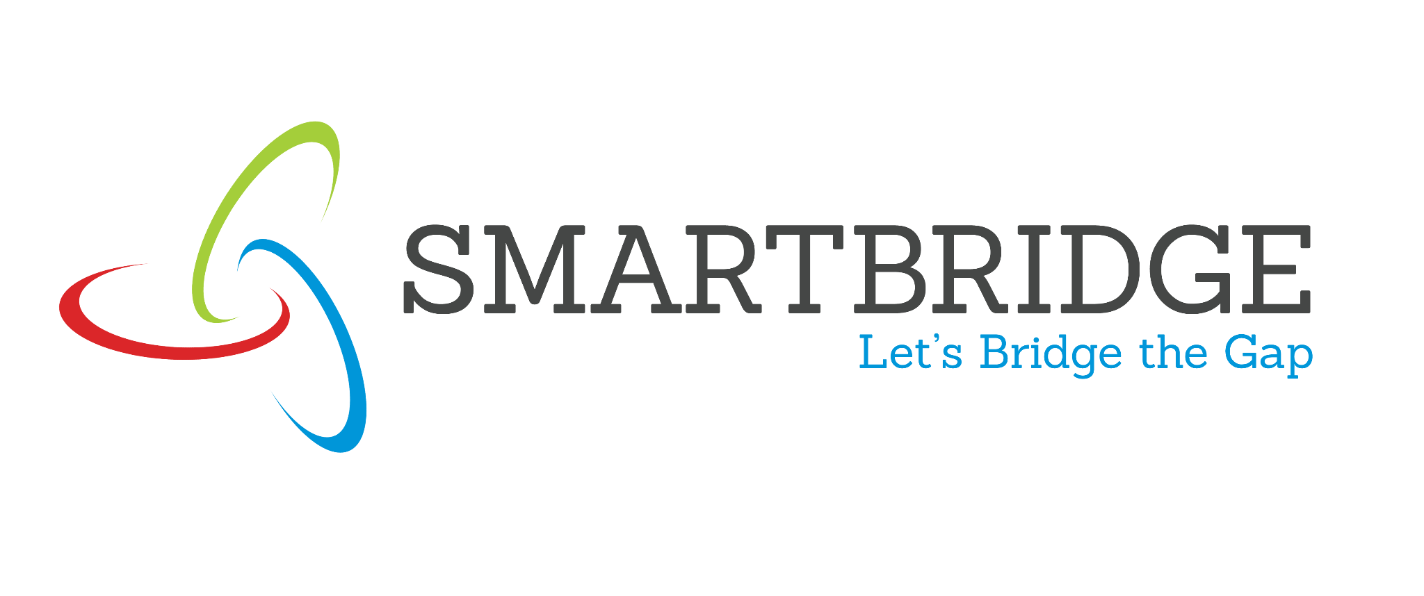 | 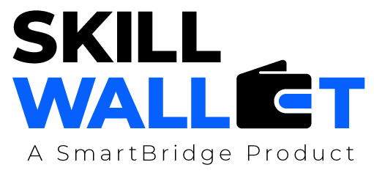
Empathy Map
Date | 15 March 2024 25 June 2026
Team ID | xxxxxx EduGenie - Google Gemini Powered Learning Assistant
Project Name | xxxxxx EduGenie - Google Gemini Powered Learning Assistant
Maximum Marks | 4 Marks
Empathy Map
Create an empathy map to understand your customer/user from four perspectives - what they Say, Think, Do, and Feel - in relation to the problem your project addresses. This helps the team build a customer-centric solution.
Ananya - Student / Self-Directed Learner
SAYS  •  * "I don't have time to read a whole chapter for one concept."• •  * "I need this explained more simply."  * "I want to test myself before the real exam." | THINKS  •  * "Am I actually understanding this, or just memorizing it?"•  •  * "Is there a faster way to learn this topic?"  * "I wish I had a personal tutor available any time."
* Searches Google / YouTube for explanations of confusing DOES  topics. topics.  •  * Rewrites lecture notes by hand to create a personal summary.•  * Asks classmates or online forums to test them with quiz-style•  questions. questions. | PERSONA  NAME  (Role / User  Type) * Anxious in the days before an exam. FEELS  •  * Overwhelmed by unstructured, lengthy material.  •  * Relieved and confident once a concept finally 'clicks'.•

